The Baghdad Gita
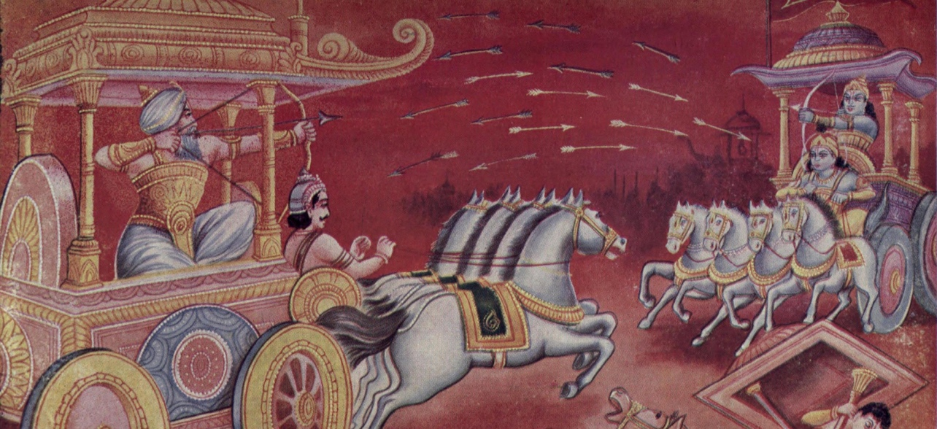

- Explain why Arjuna does not want to fight?

- What does Krishna say to Arjuna to convince him to fight?

- When Krishna tells Arjuna that arrows won’t kill the enemy, what does mean?

- What does Krishna tell Arjuna about the soul and why does he tell him this?

- Krishna describes three types of men. What are they? Do you agree with Krishna on this point?

- Describe Krishna’s view of the soul.

- How does Krishna describe even-mindedness and what keeps many of us from gaining even-mindedness?

- What is the goal of meditation?

